

Hold the frame on a soldering table with a third and fourth hand (4). Solder the joint (5). If you don’t have such a set-up, twist a couple of wires around the lantern to hold the edges to be soldered in close opposition. As there will be some gapping in the joint, use soft solder. Silver solder will not fill such a joint.

**4 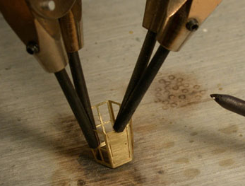 5 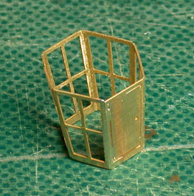 6** 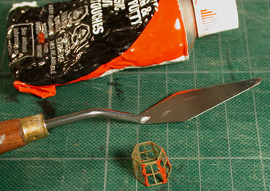

Fill the ‘V’ grooves at each corner with automotive body filler or beads of solder (6). Use a fine file to level the corners and add filler until a continuous edge is achieved.

Cut two short lengths of wire for the access door hinges. First straighten a short piece of wire by rolling it between two hard surfaces. Using a disposable knife-edge, roll it across the wire to score it all around (8). It will then snap cleanly across, leaving a squared end. A miniature rivet serves for the door handle. Epoxy them in place with a spacer under the rivet head (9). When the epoxy has almost set, remove the spacer.

**7 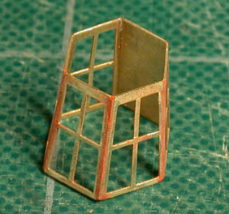 8 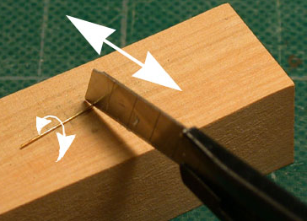 9** 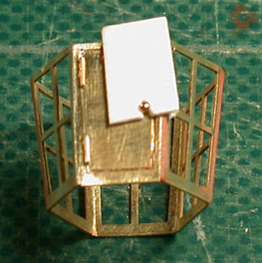

After final clean-up, gently sand top and bottom edges level (10). Lightly spray-prime the framework. Avoid a heavy coat of paint; it will fill in the corners of the mullions and spoil the scale appearance of the lantern. The original lanterns were made of iron and then painted to resemble wood (11), so you are continuing the tradition! When the primer is dry, clean up any corner that has accumulated paint using a scalpel blade.

**10 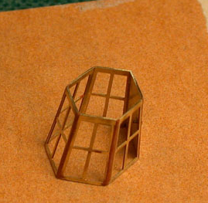 11** 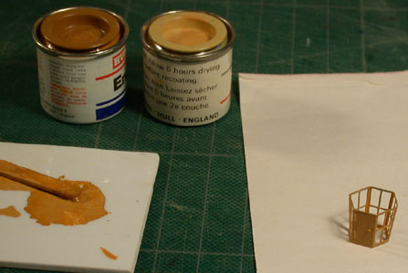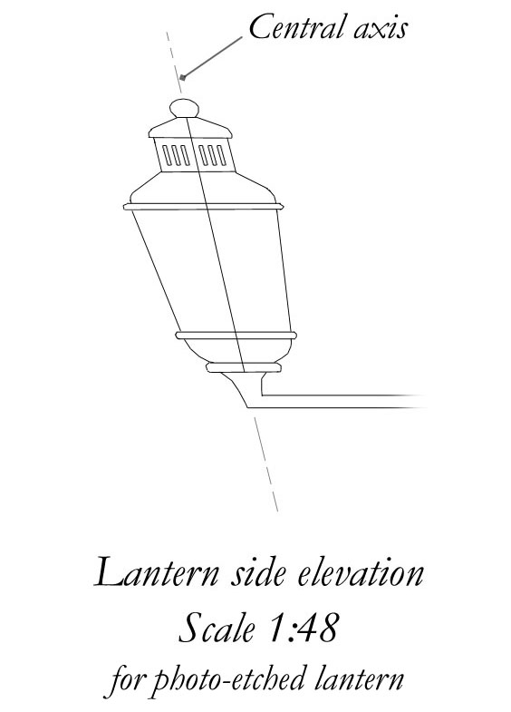

You may paint the inside and edges of the mullions and door red. This is seen on many contemporary models. Mix a color to resemble the wood you are using for the top and base to paint the outside surfaces.

The last step to complete the central section of the lantern is to fit the lights. Thin acrylic or butyrate sheet is probably easier to trim and fit than attempting to cut microscope cover glass. Use the spare photo-etched lantern to trace the patterns for the ‘glass’ pieces. They will be slightly smaller all round than their patterns. About 1/64" less all round should be about right. Carefully roughen the top and bottom edges of the plastic’s outer faces for the glue to adhere to. Use a minimum amount of glue to cement the pieces in place along the top and bottom edges.

***Note:*** *The lantern lights section provided in the photo-etched sheet is* ***not*** *identical to that illustrated in The Fully Framed Model. A drawing is provided, above, for the top and base of this particular style of lantern. For further details of crank and support rods, see Volume II, sections 12.48 and 12.49.*

Find the angle along the side bend of the lantern (12). This is the principal axis and is required in order to make the top and base sections of the lantern accurately. It should measure about 13°.

**12 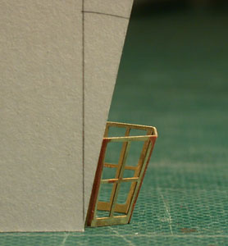 13 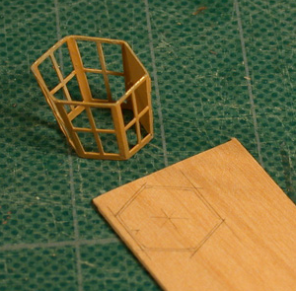 14** 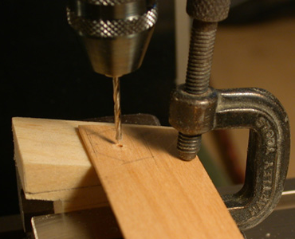

Place the completed section on a piece of paper and trace around its base to obtain a pattern for the lower rim (13). Repeat with the lantern inverted for the upper rim pattern. Trace these outlines on 1" thick stock. Find the center of each piece and drill a pilot hole at the angle you found earlier. Either use a milling setup with a tilting head or cut a temporary base at the correct angle (14). If you have a tilting table, use that. Repeat the pattern on the lower face of the stock, centering it over the pilot hole on that side. Cut out both rims. Each edge face will have a different bevel. Either round the edges over or cut a molding along each edge. Carefully epoxy the lower rim to the completed lantern center section (15). You may add a lamp or candle-holder inside to cover the pilot hole.

**15 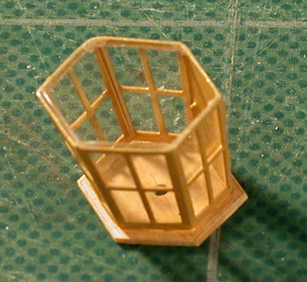 16** 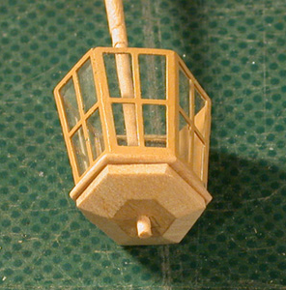

Next will be the lower section. There are two component pieces. The upper one is 4½" thick and the lower one 1½" thick. Mark out the same footprint as the lower end of the lights section on a suitable piece of stock 4½" thick. Next, mark the center point and drill at the same angle as before. Transfer the outline on the top to the under surface, remembering not to turn the tracing over. This is in case the symmetry of your lantern is not quite accurate. The central pilot hole locates the pattern for you. Cut out the piece to your mark-out on the upper surface, remembering to leave a little extra material all around.

Check the size of the lower section by threading it on a dowel run through the lower rim, making sure it is in the correct orientation (16). Adjust as necessary. Remove the lower section and invert it. Mark out the lower face. File or sand the fore and aft faces first (17), then the two side faces on each side. Aim to get the junctions of each face in straight lines as seen from above (18). Round over the edges to complete shaping it.

For added authenticity you can add beading along each angle. The original lanterns were of riveted sheet metal and angle iron, not wood. Use either fine card strips or thread, gluing them on. Match the wood color or paint the beading. Continue by making the base plate section from 1½" thick wood in the same way. This is then glued to the lower section, again using the dowel to accurately locate it (19).

**17 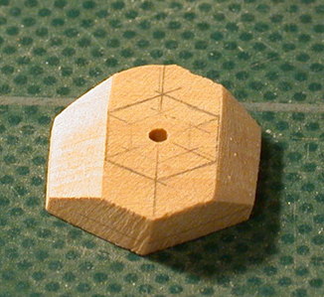 18 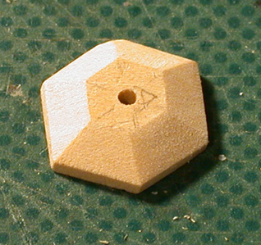 19** 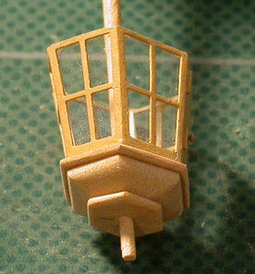

Finish the upper rim in the same way as you did the lower rim. Delay gluing this in until sure that you will not need to access the interior of the lantern again. Add any detail you wish and make sure that the inside is dust-free before gluing on the rim (20). The upper rim has two small eyebolts fitted on both corners of the forward or athwartships angles (21). These are for the two metal rods that act as braces. They secure to similar eyebolts on the tafferel.

**20 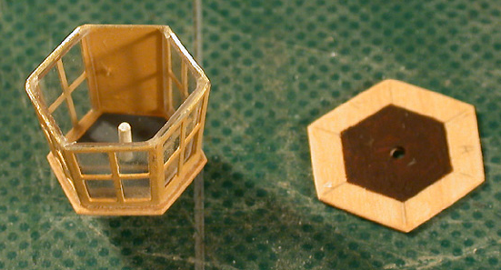 21** 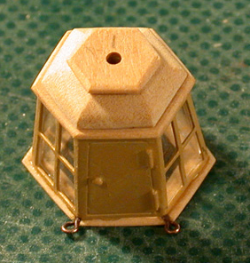

The roof section is cut from 6" thick stock and shaped, fitted, detailed and glued in the same manner as the lower section. Above this is the vent with its slots (22). Again, use the same techniques to form its outer shape. You can hollow it out carefully when complete. Glue it to the roof section (23).

**22 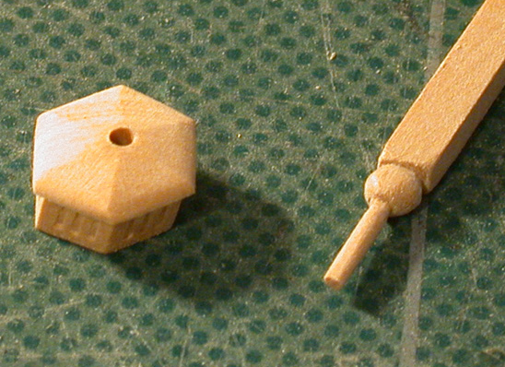 23** 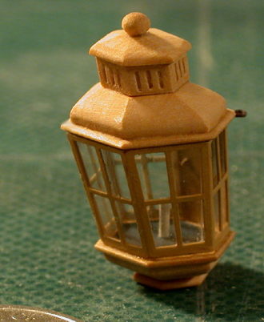

Next is the metal crank or bracket that the lantern sits on (24). This is a cutting and filing exercise. Match the pattern on the drawing and add a spigot or stem to fit the drilled hole in the lower section. I use brass sheet, but one could use wood. However, with wood I recommend half-lap jointing two pieces together to avoid cross-grain weakness. Chamfer off all sharp corners. The forward end of the bracket passes through the carved work into the tafferel. It somehow seems sacrilegious to drill through the carvings! The lantern should be placed at a level where the lower rim sits just above the tafferel. So often one sees models where lanterns are mounted far too high. The cupola and finial (22) are shaped and added to complete this jewel-like fitting. Attach it to your model; fit the support rods, then sit back to enjoy it.

**24** 