Port straps

Draught marks

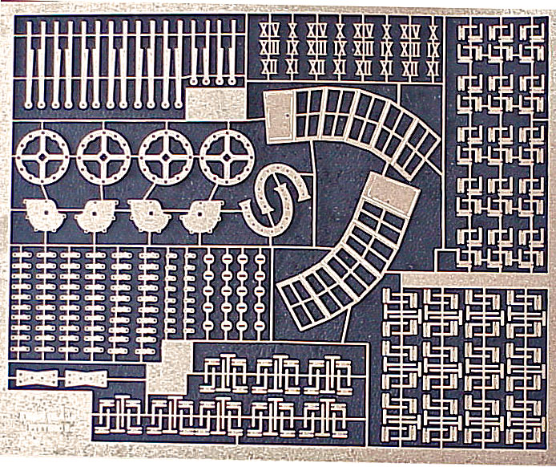

Cistern side plates

Half links

Saucers

Single & double links

Pump sprocket wheels

Horseshoe plates

Dovetail plates

Cabin door hinges

Lantern expansions (2)

Cabin door hinges

Cabin door hinges